Phys 135A College Physics I
Activity 4: Picket Fence Free Fall
We say an object is in free fall when the only force acting on it is the Earth’s gravitational force. No other forces can be acting; in particular, air resistance must be either absent or so small as to be ignored. When the object in free fall is near the surface of the earth, the gravitational force on it is nearly constant. As a result, an object in free fall accelerates downward at a constant rate. This acceleration is usually represented with the symbol g.
Physics students measure the acceleration due to gravity using a wide variety of timing methods. In this experiment, you will have the advantage of using a very precise timer connected to the computer and a Photogate. The Photogate has a beam of infrared light that travels from one side to the other. It can detect whenever this beam is blocked. You will drop a piece of clear plastic with evenly spaced black bars on it, called a Picket Fence. As the Picket Fence passes through the Photogate, the computer will measure the time from the leading edge of one bar blocking the beam until the leading edge of the next bar blocks the beam. This timing continues as all eight bars pass through the Photogate. From these measured times, the program will calculate the velocities and accelerations for this motion and graphs will be plotted.
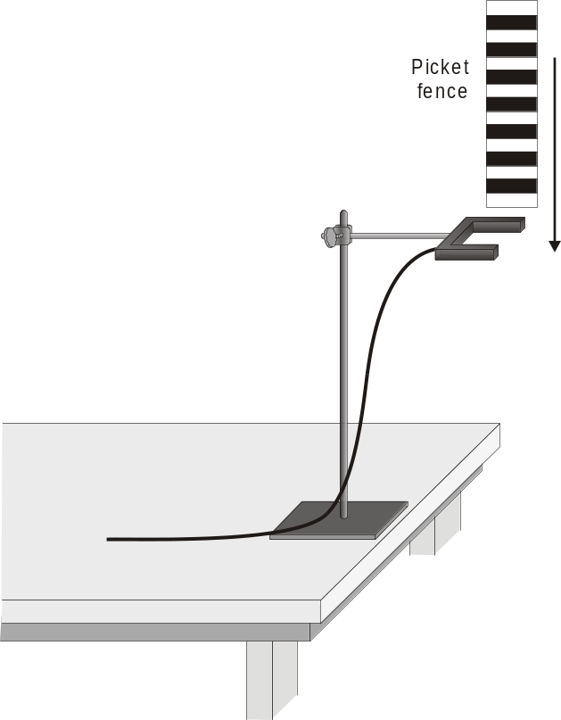
Figure 1
objective
- Measure the acceleration of a freely falling body (g) to better than 0.5% precision using a Picket Fence and a Photogate.
Materials
computer | Vernier Photogate
Vernier computer interface | Picket Fence
Logger Pro | clamp or ring stand to secure Photogate

Preliminary questions
1. Inspect your Picket Fence. You will be dropping it through a Photogate to measure g. The distance, measured from one edge of a black band to the same edge of the next band, is 5.0 cm. What additional information will you need to determine the average speed of the Picket Fence as it moves through the Photogate?

2. If an object is moving with constant acceleration, what is the shape of its velocity vs. time graph?

3. Does the initial velocity of an object have anything to do with its acceleration? For example, compared to dropping an object, if you throw it downward would the acceleration be different after you released it?

Procedure
1. Fasten the Photogate rigidly to a ring stand so the arms extend horizontally, as shown in Figure 1. The entire length of the Picket Fence must be able to fall freely through the Photogate. To avoid damaging the Picket Fence, make sure it has a soft surface (such as a carpet) to land on.
2. Connect the Photogate to the DIG/SONIC 1 input of the Vernier computer interface.
3. Open the file “05 Picket Fence” in the Physics with Computers folder.
4. Observe the reading in the status bar of Logger Pro at the top of the screen. Block the Photogate with your hand; note that the GateState is shown as Blocked. Remove your hand and the display should change to Unblocked.
5. Click  to prepare the Photogate. Hold the top of the Picket Fence and drop it through the Photogate, releasing it from your grasp completely before it enters the Photogate. Be careful when releasing the Picket Fence. It must not touch the sides of the Photogate as it falls and it needs to remain vertical. Click  to end data collection.
6. Open an Excel file and transfer the data from the Vernier program to the Excel file. In Excel, create two new columns: one for time one for distance. Plot the distance-time graph. Add trendline and extract the acceleration from the graph as you learned in the 2nd activity.
Extensions
1. Would dropping the Picket Fence from higher above the Photogate change any of the parameters you measured? Try it.

2. Would throwing the Picket Fence downward, but letting go before it enters the Photogate, change any of your measurements? How about throwing the Picket Fence upward? Try performing these experiments.

3. How would adding air resistance change the results? Try adding a loop of clear tape to the upper end of the Picket Fence. Drop the modified Picket Fence through the Photogate and compare the results with your original free fall results.

